A

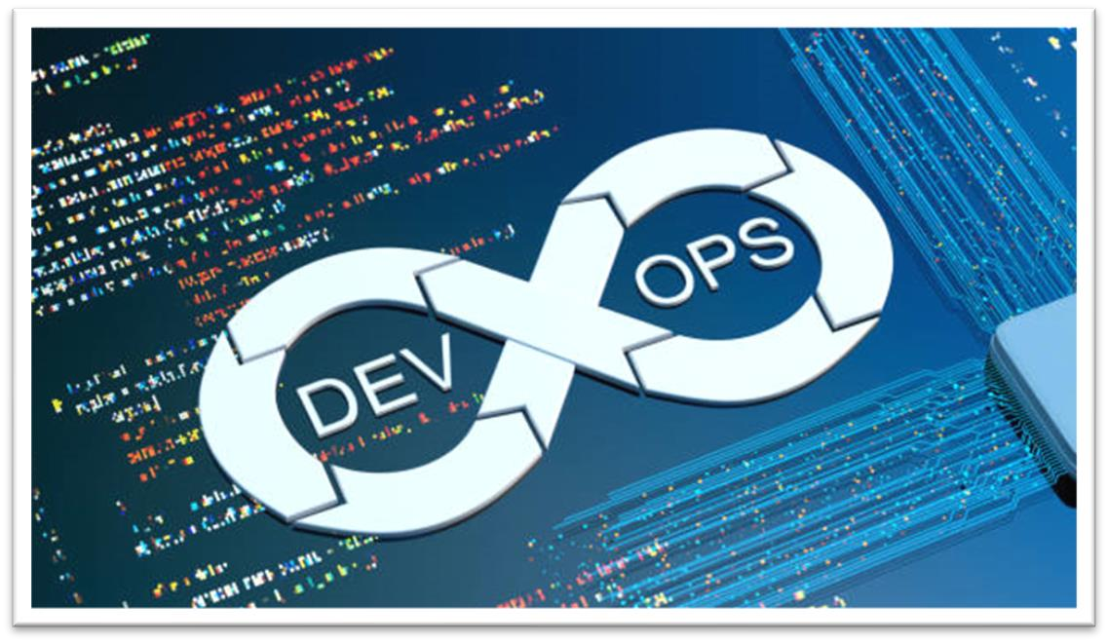

INTERNSHIP REPORT ON DEVOPS

2024

# A

**INTERNSHIP REPORT ON DEVOPS**

Submitted in accordance with the requirement for the degree of

**BACHELOR OF TECHNOLOGY IN**

**COMPUTER SCIENCE AND ENGINEERING**

## Submitted By

## DIRISANAPU MOUNIKA

**Reg. No: 20JU1A0573**

## Under the guidance of

**Dr. J. V. ANIL KUMAR, M. Tech, Ph. D**

**Professor & H.O.D, CSE Dept.**



**Department of Computer Science and Engineering**

**KRISHNA CHAITANYA INSTITUTE OF TECHNOLOGY & SCIENCES**

**(Approved by AICTE, NEW DELHI & Affiliated to JNTU, KAKINADA).**

### Accredited by NAAC, Markapur, Prakasam Dt., Andhra Pradesh.

**2020-2024**

**KRISHNA CHAITANYA INSTITUTE OF TECHNOLOGY & SCIENCES**

(Approved by AICTE, New Delhi & Affiliated to JNTU KAKINADA, Accredited by NAAC)

Devarajugattu, Peddaraveedu mandal, Prakasam dt., A.P.



**CERTIFICATE**

This is to certify that the “**Internship report”** submitted by **DIRISANAPU** **MOUNIKA**

**(20JU1A0573)** is work done by him and submitted during 2020 - 2024 academic year, in partial fulfilment of the requirements for the award of the degree of **BACHELOR OF TECHNOLOGY in COMPUTER SCIENCE AND ENGINEERING, at NARESH TECHNOLOGIES AND CONSULTANCY SERVICES.**

**Internship Guide Head of the Department**

**Dr. J. V. Anil Kumar M. Tech, Ph.D. Dr. J. V. Anil Kumar M. Tech, Ph.D.**

**Professor & H.O.D Professor & H.O.D**

**Dept. Of CSE, KITS Dept. Of CSE, KITS**

**PROGRAM BOOK FOR SEMESTER INTERNSHIP**

**Name of the Student :** Dirisanapu Mounika

**Name of the College :** Krishna Chaitanya Institute of

Technology and Sciences

**Registration Number :** 20JU1A0573 **Period of Internship :** 12 Weeks **From :** 05/02/2024

**To :** 27/04/2024

## Name & Address of the

**Intern Organization :** Naresh Technologies and

Consultancy Services

# JNTU KAKINADA UNIVERSITY

2020-24

I, **DIRISANAPU MOUNIKA,** a student of Internship Program, Reg. No. **20JU1A0573** of the Department of **COMPUTER SCIENCE & ENGINEERING, KRISHNA CHAITANYA INSTITUTE OF TECHNOLOGY & SCIENCES** do hereby declare that I have completed the mandatory internship from **05/02/2024** to **27/04/2024** in **NARESH TECHNOLOGIES AND CONSULTANCY SERVICES.**

(Signature and Date)

This is to certify that **DIRISANAPU MOUNIKA**, Reg. No. **20JU1A0573** has completed his internship in **NARESH TECHNOLOGIES AND CONSULTANCY SERVICES** on **DEVOPS** under my supervision apart of partial fulfilment of the requirement for the Degree of **BACHELOR OF TECHNOLOGY** in the Department of **COMPUTER SCIENCE & ENGINEERING, KRISHNA CHAITANYA INSTITUTE OF TECHNOLOGY & SCIENCES**.

(Signature and Date)

**Endorsements**

Head of the Department

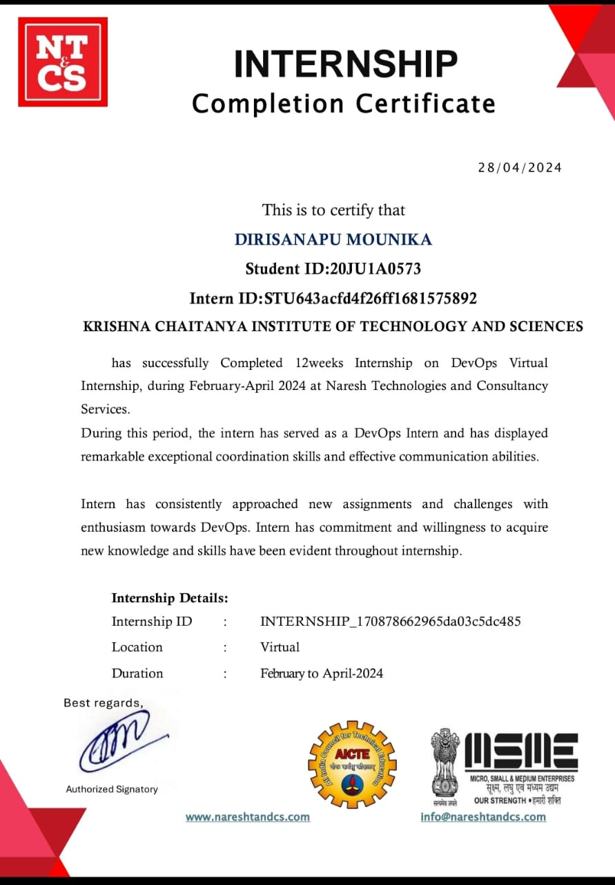

I take this opportunity to express my deep gratitude of appreciation to all those who encourage us for successful completion of the internship.

I wish to convey sincere thanks to chairman of our college **Sri. ANNA RAMBABU GARU,** and secretary and correspondent **Sri. ANNA KRISHNA CHAITANYA GARU.**

I wish to express my deepest sense of gratitude and my sincere thanks to **Dr. V. KRISHNA REDDY, PRINCIPAL** of KITS college for his suggestions.

I wish to express my sincere gratitude to **Dr. J.V. ANIL KUMAR** sir**, Professor & H.O.D,** Department of CSE, for his consistent help and encouragement to complete the internship.

I express my sincere thanks to my internship Co-Ordinator **Dr. J.V. ANIL KUMAR** sir, **Professor & H.O.D,** Department of CSE, for his suggestions and constant source of information for me.

I sincerely express thanks to my **Internship mentors** for their excellent suggestions and extended co-operation for its success.

I wholeheartedly express my thanks to all **CSE department faculty members**

for their full-fledged co-operation towards completion of my internship.

I am also thankful to all who helped me directly and indirectly in the successful completion of this internship.

## Project Associate:

DIRISANAPU MOUNIKA

20JU1A0573

CONTENTS

CHAPTER 1: EXECUTIVE SUMMARY 1

CHAPTER 2: OVERVIEW OF THE ORGANIZATION 2

CHAPTER 3: INTERNSHIP PART 4

* 1. Need for DevOps 4
  2. Internship and Its Importance 5
  3. Intern Responsibilities 6
  4. Skills Acquired during Internship 6

CHAPTER 4: WEEKLY REPORTS 8

Activity log for week – 1 8

Weekly Report 9

Activity log for week – 2 10

Weekly Report 11

Activity log for week – 3 12

Weekly Report 13

Activity log for week – 4 14

Weekly Report 15

Activity log for week – 5 16

Weekly Report 17

Activity log for week – 6 18

Weekly Report 19

Activity log for week – 7 20

Weekly Report 21

Activity log for week – 8 22

Weekly Report 23

Activity log for week – 9 24

Weekly Report 25

Activity log for week – 10 26

Weekly Report 27

Activity log for week – 11 28

Weekly Report 29

Activity log for week – 12 30

Weekly Report 31

CHAPTER 5: OUTCOMES DESCRIPTION 32

* 1. Describe the work environment you have experienced 32
  2. Describe the real time technical skills you have acquired 34
  3. Describe the Managerial skills you have acquired 45
  4. Describing how you could improve your communication skills 47
  5. Describe the technological developments you have observed

and relevant to the subject area 50

STUDENT SELF EVALUATION 52

PHOTOS & VIDEOS 53

EVALUATION 54

MARKS STATEMENT 57

Internal Assessment Statement 58

External Assessment Statement 59

# CHAPTER 1: EXECUTIVE SUMMARY

Naresh Technologies & Consultancy Services is a Training and Consultancy Services that provides internship resources and career services to students and employers. The platform offers internship searching and posting services as well as many other career services such as counselling, cover-letter writing, resume building, and training programs to students.

Naresh Technologies & Consultancy Services is a startup company. we are a technology company on a mission to equip students with relevant skills and practical exposure to help them get the best possible start to their careers. Imagine a world full of freedom and possibilities. A world where you can discover a passion and turn it into your career. A world where you graduate fully assured, confident, and prepared to stake a claim on your place in the world.

# CHAPTER 2: OVERVIEW OF THE ORGANISATION

The Andhra Pradesh State Council of Higher Education (APSCHE) collaborated with the EDUNET Foundation to provide virtual internship to more than 1.5 lakh students in the State.

APSCHE, Naresh Technologies and Consultancy Services have come together to create a unique partnership that is helping to bridge the skills gap in India. This partnership is providing students and professionals with access to high-quality, industry-relevant training in the latest technologies.

**Naresh Technologies & Consultancy Services** is a training and consultancy firm, it can be assumed that they provide services related to education, training, and consulting. Typically, such organizations offer a range of services to individuals and businesses, including:

## Training Services:

* + 1. **Technical Training:** This could include courses related to information technology, programming languages, software development, data science, etc.
    2. **Soft Skills Training:** Training in communication, leadership, teamwork, and other interpersonal skills is often provided for professional development.
    3. **Certification Programs:** Preparation courses for various industry certifications, which are essential for career growth in many fields.
    4. **Customized Training:** Tailored training programs designed specifically for businesses or organizations to enhance the skills of their employees.

## Consultancy Services:

1. **IT Consultancy:** Advising businesses on how to use information technology to meet their objectives or overcome problems.
2. **Business Process Optimization:** Analyzing and optimizing existing business processes to improve efficiency and reduce costs.
3. **Data Analysis and Interpretation:** Helping businesses make sense of data, providing insights that can be used for strategic decision-making.
4. **Project Management:** Providing expertise in managing projects, ensuring

they are completed on time and within budget.

1. **Cybersecurity Consultancy:** Advising businesses on how to protect their digital assets from cyber threats and attacks.

## Our Training Services:

At Naresh Technologies & Consultancy Services, we offer a diverse range of training programs, from technical courses covering the latest programming languages and technologies to soft skills development, ensuring that our clients are well-equipped to meet the challenges of the modern workforce.

## Our Consultancy Services:

In addition to our training programs, we provide strategic consultancy services to businesses of all sizes. Our experts work closely with clients to understand their unique needs and challenges, offering tailored solutions in areas such as IT consultancy, business process optimization, data analysis, project management, and cybersecurity.

# CHAPTER 3: INTERNSHIP PART

The decision was taken under the National Education Policy (NEP) 2020. New guidelines from the University Grants Commission (UGC) students in recognized Indian universities will have to compulsorily do research internship for eight to ten weeks. The decision was taken after it was announced under NEP 2020 that internships will now be promoted and made compulsory.

These internship program aim primarily at the employability of students and to help develop research capabilities in students.

The Govt. of Andhra Pradesh, Higher Education Department has introduced Skills and Skill Development courses along with three mandatory internships during their graduation. The Andhra Pradesh State Council of Higher education has given the instructions to all the colleges and universities. Hence, the internship is mandatory for the undergraduate students. The Commissioner of the Collegiate Education and concerned universities are the implementing authorities. Here I am going to explain the internship, Firstly I selected the domain DevOps, Attended the online classes, Read the materials for the preparation of the modules. I have successfully completed the Modules of the domain and what kind of skills I acquired etc. are discussing in this chapter.

## Need for DevOps:

DevOps is essential in today’s software development landscape for several reasons. It enables faster time to market through Continuous Integration and Continuous Delivery (CI/CD) and automation, allowing for frequent and reliable releases. Improved collaboration is achieved by breaking down silos, enhancing communication, and promoting shared responsibility between development and operations teams. This integration also leads to enhanced quality and reliability, with automated testing and consistent environments ensuring early issue detection and reducing deployment failures. DevOps provides scalability and flexibility by utilizing Infrastructure as Code (IaC) and microservices architecture, making it easy to scale resources and adapt to changing needs. Additionally, DevOps improves customer experience by enabling rapid delivery of new features

and maintaining continuous feedback loops. Finally, it offers cost efficiency by optimizing resource use, reducing downtime, and leveraging automation to save costs. Overall, DevOps accelerates software delivery while ensuring reliability and continuous improvement.

## Internship and Its Importance:

An internship is a period of work experience offered by the organization for a limited period of time. Once confined to graduates, internship is used practice for a wide range of placements in businesses, non-profit organizations and government agencies. They are typically undertaken by students and graduates looking to gain relevant skills and experience in a particular field. The students will get benefit from these placements because they often recruit employees from their best interns, who have known capabilities, thus saving time and money in the long run. Internships for professional careers are similar in some ways. Similar to internships, apprenticeships transition students from vocational school into the workforce. Interns may be college students.

In addition, an internship can be used to build a professional network that can assist with letters of recommendation or lead to future employment opportunities. The benefit of bringing an intern into full time employment is that they are already familiar with the company, therefore needing little to no training. Internships provide current college students with the ability to participate in a field of their choice to receive hands-on learning about a particular future career.

Companies in search of interns often find and place students in mostly unpaid internships, for a fee. These companies charge students to assist with research, promising to refund the fee if no internship is found. The programs vary and aim to provide internship placements at reputable companies. Some companies may also provide controlled housing in a new city, mentorship, support, networking, weekend activities or academic credit.

Some companies specifically fund scholarships and grants for low-income applicants. Critics of internship criticize the practice of requiring certain college credits to be obtained only through unpaid internships. Paying for academic credits is a way to ensure students complete the duration of the internship, since

they can hold accountable by their academic institution. For example, a student may be awarded academic credit only after their university receives a positive review from the intern’s supervisor at the sponsoring organization.

## Intern Responsibilities:

* + - Fulfilling tasks set out by the mentors from several concepts.
    - Attending the online classes on time.
    - Performing research on the basic concepts.
    - Updating social media platforms and writing copy for posts.
    - Creating images for social media posts.

## Skills Acquired during Internship:

While getting an internship is one part of the internship process, it is complete only when grasp the relevant skills through my experience. I will get to learn a lot of technical skills. Soft skills are basic necessity to become a professional.

### Technical Skills

* **CI/CD Pipelines**: Developed an understanding of setting up and managing Continuous Integration and Continuous Delivery (CI/CD) pipelines using Jenkins, facilitating automated build, test, and deployment processes.
* **Containerization**: Gained basic knowledge in using Docker for creating and managing containers, and Kubernetes for orchestrating containerized applications to ensure scalable and efficient deployments.
* **Cloud Services (Azure)**: Learned the fundamentals of utilizing Azure services for cloud infrastructure management, including Azure Virtual Machines for virtual servers, Azure Blob Storage for storage, and Azure Active Directory for security management.
* **Monitoring and Logging**: Acquired skills in using Prometheus for monitoring system performance and Grafana for visualization, along with implementing logging solutions for better troubleshooting and insights.

### Development and Automation

* **Scripting and Automation**: Enhanced proficiency in scripting languages like Python and Bash to automate repetitive tasks and improve workflow efficiency.
* **Infrastructure as Code (IaC)**: Learned to use tools like Terraform and Azure Resource Manager (ARM) templates to define and provision infrastructure through code, ensuring consistency and ease of management.
* **Version Control**: Gained experience with Git for version control, including branching, merging, and collaborating on code with team members to manage and track changes effectively.

### Other skills acquired:

* + - Communication skills.
    - Critical thinking.
    - Research and Analysis.
    - Eager to learn

# CHAPTER 4: WEEKLY REPORTS

## ACTIVITY LOG FOR WEEK – 1

|  |  |  |
| --- | --- | --- |
| **Day & Date** | **Brief description of the daily activity** | **Learning Outcome** |
| Day – 1 | Introduction of DevOps | Understanding about DevOps |
| Day - 2 | DevOps Lifecycle | Understanding about DevOps Lifecycle |
| Day – 3 | Introduction of DevOps tools | Understanding about DevOps tools |
| Day – 4 | Briefly about DevOps tools | Understanding about DevOps tools |
| Day – 5 | Introduction of Software | Understanding about Software |
| Day –6 | SDLC(Software Development Life Cycle) | Understanding about SDLC(Software Development Life Cycle) |

## WEEKLY REPORT

WEEK-1 (From to )

**Objective of the Activity Done:** Solidify understanding of DevOps principles and explore its associated tools.

**Detailed Report:** This week was a whirlwind introduction to version control! I learned about source code management (SCM) and its power to track changes in code. Git, a popular SCM system, emerged as a key tool for collaboration. We explored how Git empowers developers to work together seamlessly by allowing them to track changes, revert to previous versions, and stay in sync. The discussions also introduced GitHub, a platform built on Git that seems like a central hub for developers to share code, collaborate, and learn from each other.

## ACTIVITY LOG FOR WEEK – 2

|  |  |  |
| --- | --- | --- |
| **Day & Date** | **Brief description of the daily activity** | **Learning Outcome** |
| Day – 1 | Introduction of SDLC Models | Understanding about SDLC Models |
| Day - 2 | Introduction of Waterfall Model | Understanding about Waterfall Model |
| Day – 3 | Introduction of Spiral Model | Understanding about Spiral Model |
| Day – 4 | Introduction of V-Model | Understanding about V-Model |
| Day – 5 | Introduction of Agile Model | Understanding about Agile Model |
| Day –6 | Discussing about All Models in DevOps | Remembering about All Models in DevOps |

## WEEKLY REPORT

WEEK-2 (From to )

**Objective of the Activity Done:** Gain foundational knowledge of SDLC models for context in DevOps practices.

**Detailed Report:** This week, I embarked on a journey through the world of SDLC (Software Development Life Cycle) models. We explored various models, providing a framework for understanding the different approaches to software development. The waterfall model, a linear and sequential approach, offered a starting point. Next, we delved into the spiral model, which emphasizes risk management through iterative cycles. The V-model, with its focus on verification and validation alongside development stages, presented another perspective. Finally, I explored the agile model, known for its flexibility and iterative development in response to changing requirements. Understanding these models provides valuable context for how DevOps practices integrate with different software development methodologies.

## ACTIVITY LOG FOR WEEK - 3

|  |  |  |
| --- | --- | --- |
| **Day & Date** | **Brief description of the daily activity** | **Learning Outcome** |
| Day – 1 | Introduction of Scrum | Understanding about Scrum |
| Day - 2 | Introduction of Azure Admin | Understanding about Azure Admin |
| Day – 3 | Azure Admin importance in DevOps | Understanding about Azure Admin importance in DevOps |
| Day – 4 | Recalling Azure Admin Part | Understanding about Azure Admin Part |
| Day – 5 | Creating a Microsoft Azure Account | Understanding about Microsoft Azure Creation |
| Day –6 | Creating a Linux Virtual Machine (Linux VM) | Learn how to create VM |

## WEEKLY REPORT

WEEK-3 (From to )

**Objective of the Activity Done:** Explore Scrum methodology and gain hands-on experience with Azure administration.

**Detailed Report:** This week offered a powerful combination of project management and cloud administration. We explored Scrum, an agile methodology, highlighting its collaborative and iterative approach to software development. Next, I delved into Azure administration, understanding its importance in managing cloud resources. Feeling equipped, I created a Microsoft Azure account, unlocking access to the platform. The week's highlight was creating my first Linux Virtual Machine (VM) in Azure. Mastering VM creation equips me with a crucial DevOps skill: provisioning and managing cloud infrastructure.

## ACTIVITY LOG FOR WEEK - 4

|  |  |  |
| --- | --- | --- |
| **Day & Date** | **Brief description of the daily activity** | **Learning Outcome** |
| Day – 1 | Introduction of Linux | Understanding about Linux |
| Day - 2 | Discussing about Operating systems | Understanding about Operating systems |
| Day – 3 | Discussing about Types of Linux | Understanding about  Types of Linux |
| Day – 4 | Introduction of Linux Commands | Understanding about Linux Commands |
| Day – 5 | Discussing about Basic Linux commands | Understanding about Basic Linux commands |
| Day –6 | Connecting to azure Linux VM in Putty | Understanding about Connecting to azure Linux VM in putty |

## WEEKLY REPORT

WEEK-4 (From to )

**Objective of the Activity Done:** Grasp Linux fundamentals for navigating Azure environments.

**Detailed Report:** This week, I explored Linux, a powerful and efficient operating system. We discussed the role of operating systems in managing computer resources. Linux comes in various distributions, each catering to specific needs. We then dipped our toes into basic Linux commands, the language for interacting with the system. Finally, I learned how to connect to an Azure Linux VM using PuTTY, a crucial skill for managing Linux systems within the Azure cloud. This foundational knowledge of Linux equips me for further exploration in the exciting world of DevOps.

## ACTIVITY LOG FOR WEEK - 5

|  |  |  |
| --- | --- | --- |
| **Day & Date** | **Brief description of the daily activity** | **Learning Outcome** |
| Day – 1 | Introduction of Azure DevOps | Understanding about Azure DevOps |
| Day - 2 | Key Features and Benefits of Azure DevOps | Learn about Key Features & Benefits of Azure DevOps |
| Day – 3 | Creating Azure DevOps Account | Learn about Azure DevOps Account |
| Day – 4 | Creating a Project in Azure DevOps | Understanding about Creation of Project in Azure DevOps |
| Day – 5 | Introduction of Azure Boards | Understanding about Azure Boards |
| Day –6 | Types of Azure Boards | Understanding about Types of Azure Boards |

## WEEKLY REPORT

WEEK-5 (From to )

**Objective of the Activity Done:** Gain a comprehensive understanding of Azure DevOps and its core functionalities.

**Detailed Report:** This week, we dove into Azure DevOps, a platform for DevOps practices. We explored its core functionalities, including version control, CI/CD, project management, and collaboration tools. We learned to create an Azure DevOps account and project. We also explored Azure Boards, a key component for work management using Kanban boards and work item tracking.

## ACTIVITY LOG FOR WEEK - 6

|  |  |  |
| --- | --- | --- |
| **Day & Date** | **Brief description of the daily activity** | **Learning Outcome** |
| Day – 1 | Introduction about Source Code Management | Understanding about Source Code Management |
| Day - 2 | Introduction to Git | Understanding about What is Git |
| Day – 3 | Discussing about Main Benefits of Using GitHub | Understanding about Main Benefits of Using GitHub |
| Day – 4 | Discussing about What Is Version Control | Understanding about Version Control |
| Day – 5 | Introduction of Git Bash | Understanding about Git Bash |
| Day –6 | Installing Git Bash in Windows | Understanding how to install Git Bash in Windows |

## WEEKLY REPORT

WEEK-6 (From to )

**Objective of the Activity Done:** Establish a strong foundation in version control with Git and GitHub.

**Detailed Report:** This week delved into the core principles of version control and explored Git and GitHub as essential tools. We began with an introduction to source code management (SCM), understanding its role in managing code versions and facilitating collaboration. Next, we transitioned to exploring Git, a popular SCM system, gaining insights into its functionalities and benefits. To solidify our understanding, we discussed the key advantages of using GitHub, a prominent Git-based platform for hosting code repositories and collaborating on software projects. Following this, the focus shifted to version control itself. We explored the concept of version control, understanding how it tracks changes, enables rollbacks, and streamlines collaborative development. To further solidify our knowledge of Git, we were introduced to Git Bash, a command-line interface for interacting with Git repositories. Finally, we learned the process of installing Git Bash on Windows, equipping ourselves with the necessary tools to start using Git effectively. Overall, this week provided a comprehensive foundation in version control concepts, Git functionalities, and the benefits of using GitHub, preparing us to delve deeper into practical Git commands and workflows in the coming weeks.

## ACTIVITY LOG FOR WEEK - 7

|  |  |  |
| --- | --- | --- |
| **Day & Date** | **Brief description of the daily activity** | **Learning Outcome** |
| Day – 1 | Introduction on Git Commands | Understanding about Git Commands |
| Day - 2 | Discussing How to perform Git Commands | Understanding about How to perform Git Commands |
| Day – 3 | Performing on Git Commands | Learn on performing Git Commands |
| Day – 4 | Discussing about Linux Operating System | Learn about Linux Operating System |
| Day – 5 | Test on Performing Git Commands | Learn about Git Commands |
| Day –6 | Connecting to Azure Linux VM using Git Bash | Understanding about Azure Linux VM using Git Bash |

## WEEKLY REPORT

WEEK-7 (From to )

**Objective of the Activity Done:** Master essential Git commands and leverage them for DevOps tasks on Azure.

**Detailed Report:** This week, I sharpened my Git skills for seamless integration with Azure DevOps. I actively practiced various commands, solidifying my understanding and gaining confidence in using Git effectively. We also explored Linux operating systems, a common platform for DevOps tools, which broadened my knowledge of the environments where Git commands are frequently used. Overall, this week's focus on Git commands and their connection to Azure DevOps equipped me with the necessary skills to navigate development workflows more efficiently.

## ACTIVITY LOG FOR WEEK - 8

|  |  |  |
| --- | --- | --- |
| **Day & Date** | **Brief description of the daily activity** | **Learning Outcome** |
| Day – 1 | Connecting to GitHub Repository using Git Bash | Understanding about GitHub Repository using Git Bash |
| Day - 2 | Discussing about GitHub Repository | Understanding about GitHub Repository |
| Day – 3 | Discussing about Git Bash | Understanding about Git Bash |
| Day – 4 | Small Quiz on previous topics | Learn new things in that Quiz |
| Day – 5 | Discussing about How to connect Azure DevOps Repository using Git Bash | Understanding about How to connect Azure DevOps Repository using Git Bash |
| Day –6 | Connecting to Azure DevOps Repository using Git Bash | Understanding about Azure DevOps Repository using Git Bash |

## WEEKLY REPORT

WEEK-8 (From to )

**Objective of the Activity Done:** Bridge the gap between version control systems and DevOps pipelines.

**Detailed Report:** This week focused on connecting the dots between version control with Git Bash and DevOps pipelines in Azure DevOps. I started by revisiting GitHub repositories and explored how to interact with them using Git Bash commands. This deepened my understanding of Git Bash functionalities within the context of GitHub. To solidify my knowledge, I participated in a quiz that covered previous topics. Following this, the discussion shifted to connecting Azure DevOps repositories using Git Bash. By understanding the process, I gained insights into how version control integrates with Azure DevOps pipelines. Finally, I delved into connecting to Azure DevOps repositories directly using Git Bash commands, solidifying the connection between these two powerful tools. Overall, this week provided a practical understanding of how Git Bash serves as a bridge between version control and DevOps workflows in Azure DevOps.

## ACTIVITY LOG FOR WEEK - 9

|  |  |  |
| --- | --- | --- |
| **Day & Date** | **Brief description of the daily activity** | **Learning Outcome** |
| Day – 1 | Introduction on Azure Pipelines | Understanding about Azure pipelines |
| Day - 2 | Introduction on Continuous Integration & Continuous development | Understanding about Continuous integration & Continuous  development |
| Day – 3 | Azure pipeline creation | Understanding about Azure pipeline Creation |
| Day – 4 | Introduction on YAML and YAML Editor | Understanding about YAML & YAML Editor |
| Day – 5 | Introduction on Self Hosted Agents | Understanding about Self Hosted Agents |
| Day –6 | Discussing How to Configure Self Hosted Agents In Azure DevOps | Understanding about How to configure Self Hosted Agents In  Azure DevOps |

## WEEKLY REPORT

WEEK-9 (From to )

**Objective of the Activity Done:** Master the fundamentals of Azure DevOps pipelines for CI/CD.

**Detailed Report:** This week, I dove deep into Azure Pipelines, a central component of Azure DevOps for automating CI/CD workflows. I began by understanding the core concepts of continuous integration (CI) and continuous delivery (CD), which underpin the efficiency of Azure Pipelines. Next, I explored the process of creating Azure pipelines, gaining insights into the steps involved. To effectively define pipelines, I delved into the world of YAML and explored the functionalities of YAML editors. Furthermore, I learned about self-hosted agents, a powerful feature of Azure Pipelines that allows for running pipelines on your own infrastructure. The week concluded with a discussion on configuring self-hosted agents within Azure DevOps, equipping me with the knowledge to leverage this flexibility. Overall, this week provided a comprehensive understanding of Azure Pipelines and their role in streamlining CI/CD processes.

## ACTIVITY LOG FOR WEEK - 10

|  |  |  |
| --- | --- | --- |
| **Day & Date** | **Brief description of the daily activity** | **Learning Outcome** |
| Day – 1 | Introduction on Jenkins | Understanding about Jenkins |
| Day - 2 | Pipeline concepts and Pipeline syntax overview | Understanding about Pipeline concepts |
| Day – 3 | Introduction on Docker | Understanding about Docker |
| Day – 4 | Introduction on Kubernetes | Understanding about Kubernetes |
| Day – 5 | Introduction on Power BI | Understanding about Power BI |
| Day –6 | Power BI Deployment Pipelines | Understanding about Power BI Deployment Pipelines |

## WEEKLY REPORT

WEEK-10 (From to )

**Objective of the Activity Done:** Broaden knowledge of DevOps tools and data visualization techniques.

**Detailed Report:** This week, I expanded my horizons into DevOps tools and data visualization. I started by getting introduced to Jenkins, a popular automation server used for continuous integration and continuous delivery (CI/CD). Next, I delved into the concept of pipelines within Jenkins, gaining an overview of their syntax and functionality. To further explore the DevOps landscape, I familiarized myself with Docker, a platform for containerizing applications. Additionally, I received an introduction to Kubernetes, a container orchestration system that manages containerized applications. Shifting gears to data visualization, I explored Power BI, a business intelligence tool for creating interactive reports and dashboards. I concluded the week by learning about Power BI deployment pipelines, which automate the process of deploying Power BI reports. Overall, this week provided a valuable foundation in DevOps tools and data visualization techniques.

## ACTIVITY LOG FOR WEEK - 11

|  |  |  |
| --- | --- | --- |
| **Day & Date** | **Brief description of the daily activity** | **Learning Outcome** |
| Day – 1 | Introduction of GitHub | Understanding about GitHub |
| Day - 2 | Advantages & Disadvantages of GitHub | Understanding about Advantages & Disadvantages of GitHub |
| Day – 3 | Types of Commands & Syntaxes of Commands | Understanding about Types of  Commands & Syntaxes of Commands |
| Day – 4 | Introduction of Jupyter & Jupyter Notebook | Understanding about Jupyter & Jupyter Notebook |
| Day – 5 | Jupyter Documentation & File Formats | Understanding about Jupyter Documentation & File Formats |
| Day –6 | Anaconda Installation & Features of Anaconda | Understanding about Anaconda |

## WEEKLY REPORT

WEEK-11 (From to )

**Objective of the Activity Done:** Establish a strong foundation in data science tools.

**Detailed Report:** This week, I dived into the world of data science, exploring key platforms and tools. I started by demystifying GitHub, a version control system crucial for collaboration, and learned about its advantages and limitations. Next, I ventured into Jupyter and Jupyter Notebook, powerful environments for interactive data analysis and visualization. I familiarized myself with resources for mastering Jupyter, including its documentation and file formats. Finally, I began my exploration of Anaconda, a popular data science platform with features that streamline data science projects. Overall, this week provided a solid base in essential data science tools.

## ACTIVITY LOG FOR WEEK - 12

|  |  |  |
| --- | --- | --- |
| **Day & Date** | **Brief description of the daily activity** | **Learning Outcome** |
| Day – 1 | Introduction of Python Libraries | Understanding about Python Libraries |
| Day - 2 | Pandas in Python Library | Understanding about Pandas in Python Library |
| Day – 3 | NumPy in Python Library | Understanding about NumPy in Python Library |
| Day – 4 | Matplotlib in Python Library | Understanding about Matplotlib in Python Library |
| Day – 5 | Seaborn in Python Library | Understanding about Seaborn in Python Library |
| Day –6 | Terraform | Understanding about Terraform |

## WEEKLY REPORT

WEEK-12 (From to )

**Objective of the Activity Done:** To develop proficiency in key Python libraries for data manipulation and visualization and to gain practical experience with Terraform for Infrastructure as Code (IaC).

**Detailed Report:** In this week, I learned to use Pandas for data cleaning and analysis, and NumPy for efficient numerical computations. I explored Matplotlib and Seaborn for creating detailed and attractive visualizations. Additionally, I gained hands-on experience with Terraform, using it to define and manage infrastructure on Azure. This included writing configuration files and applying consistent infrastructure changes. These skills collectively enhanced my ability to handle data and manage cloud infrastructure effectively.

# CHAPTER 5: OUTCOMES DESCRIPTION

## Describe the work environment you have experienced:

The culture at the company ensures that everyone feels supported and welcome. People genuinely want you to succeed and feel confident in your job. I learned a lot and felt set up to succeed at my next job. I'm so impressed with Naresh Technologies and Consultancy Services. I've never worked at a place that offered me so much flexibility in how I use/spend my benefits, my hours, my work location, etc. Management is very supportive and leadership has an open door. Things move fast, so that can be different for people, but the trade-off is that you're doing work that really matters. You can consider yourself lucky when joining this company. Products are excellent. It’s a leader in the field. Culture is inclusive and friendly. The benefit package is one of the best out there.

Naresh Technologies and Consultancy Services used to have an amazing culture but that has slipped away. The company touts care for yourself but in practice, most people I have worked with throughout the company are constantly stressed out at work and do not have a good work- life balance if they are able to deliver on the expectations of work. understanding politics is also extremely helpful. With all that said there is constant change and the company is growing quickly. There are plenty of learning opportunities and if you are lucky enough to get a good manager/team the experience may differ. Naresh Technologies and Consultancy Services is rated 4.7 out of 5, based on 10 reviews by employees on Ambition Box. Naresh Technologies and Consultancy Services is known for Job Security which is rated at the top and given a rating of 4.7. However, Career growth is rated the lowest at 4.0 and can be improved. The company had a GREAT work culture and strong technology. It still has strong technology but the culture has changed rather dramatically over the last four or five years. It's also grown by about 3x in that time, and some culture change is natural in that sort of accelerated growth mode. Still, there used to be a bit of a work-life balance there. But over all the people there are quite smart and hardworking. It just got to be much more of a grind in the pandemic. And working fully remote didn't help that much.

About 53% of the employees at Naresh Technologies and Consultancy Services work 8 hours or less, while 7% of them have an extremely long day - longer than twelve

hours. Overall, the employees at Naresh Technologies and Consultancy Services are extremely happy, based on their aggregated ratings of future outlook, customer perception, and their excitement going to work.

I love what I do, which allows me to expand my technical knowledge constantly. I love that technology is constantly changing and I'm never bored. IBM is always striving to be the best in the market and this takes work. This takes work on everyone's part and I'm not disappointed in how this is accomplished by this company. It's still in a great place employee wise. Some “best of breed" technologies have gotten so large, they have lost their way, their focus and have become so political internally that the customer, aka users aren't the priority anymore. I have worked for some of them too. Security was a career change for me a year ago and they took a chance on me and all my technology background in different areas. I have no complaints. It was a great decision.

It provides benefits that put you in the driver’s seat giving you the final say of what you need and how you get it. We offer benefits and resources to meet you wherever you are in life to make sure you and your family are healthy, supported and protected. We value your health and provide options so you can choose what best supports your lifestyle and personal health goals. A variety of nationwide plans including Anthem Blue Cross, Kaiser Permanente, Dental Guard, VSP and more are available to you and your family. Our providers offer the flexibility you want and the coverage you need. Professional development is serious business at Naresh Technologies and Consultancy Services, where the Talent Development team offers 25+ courses to help employees boost their careers and develop leadership capability.

Most roles are eligible for equity grants, and we now offer new hires a quarterly vesting schedule right away. We want you to be fairly compensated and rewarded as soon as you make an impact on our team, that happens immediately and because we consider every employee a stakeholder in our long-term success, we offer an Employee Stock Purchase Plan (ESPP) with a 24-month lookback. From life insurance to health savings accounts, we provide ways to help you protect and grow your wealth. Naresh Technologies and Consultancy Services offers both traditional and Roth 401(k) options. In addition to paid corporate holidays, Flexible Time Off programs empower our employees to balance their work schedules with personal time off. We offer 12 weeks of full pay for medical leave and 6 weeks of full pay for parental leave.

## Describe the real time technical skills you have acquired:

During the 12 weeks DevOps internship, I gained valuable hands-on experience in various DevOps tools and practices. This included learning how to set up and manage cloud infrastructure using Azure, automate deployment processes using Terraform, and utilize Python libraries such as Pandas, NumPy, Matplotlib, and Seaborn for data analysis and visualization. Additionally, I developed a strong understanding of CI/CD pipelines, containerization using Docker.

## Introduction of DevOps:

DevOps is basically a combination of two words- Development and Operations. DevOps is a culture that implements the technology in order to promote collaboration between the developer team and the operations team to deploy code to production faster in an automated and repeatable way.

## Why DevOps?

The goal of DevOps is to increase an organization’s speed when it comes to delivering applications and services. Many companies have successfully implemented DevOps to enhance their user experience including Amazon, Netflix, etc.

Facebook’s mobile app which is updated every two weeks effectively tells users you can have what you want and you can have it. Now ever wondered how Facebook was able to do social smoothing? It’s the DevOps philosophy that helps Facebook ensure that apps aren’t outdated and that users get the best experience on Facebook. Facebook accomplishes this true code ownership model that makes its developers responsible that includes testing and supporting through production and delivery for each kernel of code. They write and update their true policies like this but Facebook has developed a DevOps culture and has successfully accelerated its development lifecycle.

Industries have started to gear up for digital transformation by shifting their means to weeks and months instead of years while maintaining high quality as a result. The solution to all this is- DevOps.

## DevOps Lifecycle

The DevOps lifecycle is a continuous process that combines development and operations practices to improve collaboration, automation, and efficiency in software delivery. It typically includes stages such as planning, coding, building, testing, releasing, deploying, operating, and monitoring. Each stage focuses on integrating feedback and improvements, leading to faster delivery of high-quality software.

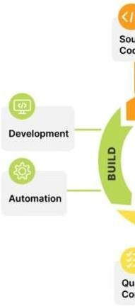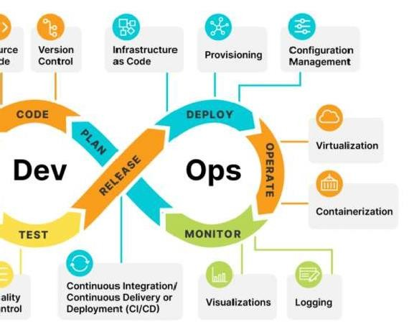

* **Plan:** Determining the commercial needs and gathering the opinions of end-user by professionals in this level of the DevOps lifecycle.
* **Code:** At this level, the code for the same is developed and in order to simplify the design, the team of developers uses tools and extensions that take care of security problems.
* **Build:** After the coding part, programmers use various tools for the submission of the code to the common code source.
* **Test:** This level is very important to assure software integrity. Various sorts of tests are done such as user acceptability testing, safety testing, speed testing, and many more.
* **Release:** At this level, everything is ready to be deployed in the operational environment. This involved continuous Integration (CI) and Continuous Deployment (CD).
* **Deploy:** In this level, Infrastructure-as-Code assists in creating the operational infrastructure and subsequently publishes the build using various DevOps lifecycle tools.
* **Operate:** At this level, the available version is ready for users to use. Here, the department looks after the server configuration and deployment.
* **Monitor:** The observation is done at this level that depends on the data which is gathered from consumer behavior, the efficiency of applications, and from various other sources.

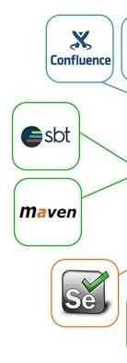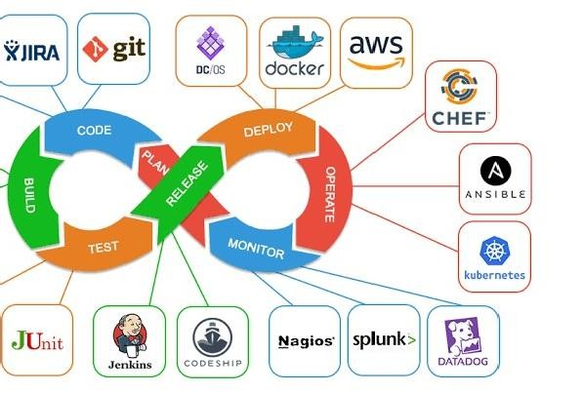

## SDLC

**SDLC** is a systematic process for building software that ensures the quality and correctness of the software built. SDLC process aims to produce high-quality software that meets customer expectations. The system development should be complete in the pre-defined time frame and cost. SDLC consists of a detailed plan which explains how to plan, build, and maintain specific software. Every phase of the SDLC life Cycle has its own process and deliverables that feed into the next phase. SDLC stands for **Software Development Life Cycle** and is also referred to as the Application Development lifecycle.

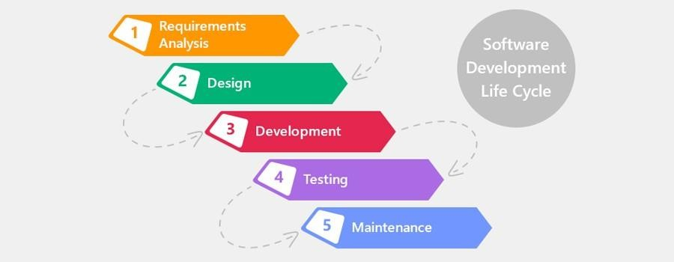

## AWS (Amazon Web Services)

### Overview:

* + - **Cloud Computing Platform**: AWS provides a vast array of cloud services, including computing, storage, databases, machine learning, and more.
    - **Global Infrastructure**: AWS operates data centers worldwide, allowing you to deploy resources close to your users.
    - **Pay-as-You-Go Model**: Pay only for what you use, with no upfront costs.

### Key Services:

1. **EC2 (Elastic Compute Cloud)**:
   * Launch virtual servers (instances) with various OS options.
   * Choose instance types based on compute power, memory, and storage.
   * Auto Scaling for dynamic workload adjustments.

### S3 (Simple Storage Service):

* + Object storage for files, images, videos, etc.
  + High durability and availability.
  + Versioning, lifecycle policies, and access control.

### Lambda:

* + Serverless compute service.
  + Execute code in response to events (e.g., file upload, API call).
  + No server management required.

### IAM (Identity and Access Management):

* + Manage user access to AWS resources.
  + Create users, groups, roles, and policies.
  + Follow the principle of least privilege.

### VPC (Virtual Private Cloud):

* + Isolate network resources within AWS.
  + Define subnets, route tables, security groups.

## Azure

* Connect VPCs using VPN or Direct Connect.

### Overview:

* + **Microsoft’s Cloud Platform**: Azure offers similar services to AWS.
  + **Integration with Microsoft Products**: Seamlessly integrates with Windows Server, Active Directory, Office 365, etc.
  + **Azure Resource Manager (ARM)**: Infrastructure as Code (IaC) for managing Azure resources.

### Key Services:

1. **Virtual Machines (VMs)**:
   * Deploy Windows or Linux VMs.
   * Choose from various VM sizes.
   * Availability Sets for high availability.

### Azure Blob Storage:

* + Object storage for unstructured data.
  + Hot, cool, and archive tiers.
  + Static website hosting.

### Azure Functions:

* + Serverless compute for event-driven applications.
  + Triggered by events (e.g., HTTP requests, timers).
  + Supports multiple languages.

### Azure DevOps:

* + CI/CD platform with pipelines, boards, and repositories.
  + Integrates with GitHub, Jenkins, and other tools.
  + YAML-based pipeline definitions.

### Azure Networking:

* + Virtual networks (VNets), subnets, NSGs.
  + Azure Load Balancer, Application Gateway.

## Jenkins

* ExpressRoute for private connectivity.

### Overview:

* + **Continuous Integration (CI)**: Jenkins automates build, test, and deployment processes.
  + **Pipeline as Code**: Define build pipelines using Jenkins files (declarative or scripted).
  + **Plugins**: Extensive plugin ecosystem for integrating with other tools.

### Key Concepts:

1. **Jenkins Master-Slave Architecture**:
   * Jenkins master coordinates builds.
   * Agents (slaves) execute build jobs.
   * Scalability and distribution.

### Security in Jenkins:

* + Configure authentication (LDAP, SAML).
  + Authorization matrix for fine-grained access control.
  + Credentials management.

### Pipeline Syntax:

* + Stages, steps, and parallel execution.
  + Integration with Git repositories.

## GitHub

* Artifacts and archiving.

### Overview:

* + **Version Control**: GitHub hosts Git repositories.
  + **Collaboration and Code Review**: Pull requests, branches, and forks.
  + **GitHub Actions**: CI/CD workflows defined in YAML.

### Key Features:

1. **Repositories**:
   * Create, clone, and manage repositories.
   * README files, license, and. Git ignore.
   * Branch protection rules.

### Pull Requests (PRs):

* + Review code changes.
  + Merge PRs after approval.
  + Automated checks (CI, linting).

### GitHub Actions:

* + Define workflows in YAML.
  + Triggered by events (push, PR, schedule).
  + Matrix builds, caching, and secrets.

## Terraform

### Overview:

* + **Infrastructure as Code (IaC)**: Terraform allows you to define and provision infrastructure using declarative configuration files.
  + **Providers**: Terraform supports various cloud providers (AWS, Azure, GCP, etc.).
  + **State Management**: Terraform maintains a state file to track the deployed infrastructure.
  + **Modules**: Reusable components for organizing and sharing Terraform code.

### Key Concepts:

1. **HCL (Hashi Corp Configuration Language)**:
   * Write infrastructure code in HCL.
   * Define resources (VMs, networks, databases) using Terraform syntax.
   * Variables, data sources, and outputs.

### Resource Blocks:

* + Declare resources (e.g., AWS EC2 instance, Azure VNet) in your Terraform configuration.
  + Specify resource properties (size, region, tags).

### Providers:

* + Configure providers (AWS, Azure, etc.) in your Terraform files.
  + Authenticate using access keys or roles.

### State Files:

* + Terraform maintains a state file (terraform. tfstate) to track resource status.
  + Store state remotely (e.g., in an S3 bucket) for collaboration.

### Modules:

* + Organize your Terraform code into reusable modules.
  + Share modules across projects.
  + Input variables and output values.

## Docker

### Overview:

* + **Containerization**: Docker allows you to package applications and their dependencies into containers.
  + **Docker Images**: Create images from Docker files and share them via registries (like Docker Hub).
  + **Containers vs. VMs**: Understand the difference between containers and virtual machines.

### Key Concepts:

1. **Docker file**:
   * Define instructions for building a Docker image.
   * Specify base image, install software, copy files, set environment variables.
   * Build images using docker build.

### Docker Images and Containers:

* + Images are read-only templates for containers.
  + Containers are running instances of images.
  + Use docker run to start containers.

### Docker Compose:

* + Define multi-container applications using a YAML file (docker- compose. yml).
  + Specify services, networks, volumes.
  + Simplifies managing complex setups.

### Networking and Volumes:

* + Containers communicate via networks.
  + Bind volumes for persistent data storage.
  + Bridge, host, and overlay networks.

## Kubernetes

### Overview:

* + **Container Orchestration**: Kubernetes automates deployment, scaling, and management of containerized applications.
  + **Pods, Services, and Deployments**: Basic building blocks in Kubernetes.
  + **Kubectl**: Command-line tool for interacting with Kubernetes clusters.

### Key Concepts:

1. **Pods**:
   * Smallest deployable units in Kubernetes.
   * One or more containers within a pod.
   * Share network and storage.

### Services:

* + Expose pods to the network.
  + Cluster IP, Node Port, Load Balancer.
  + DNS-based service discovery.

### Deployments:

* + Manage replica sets.
  + Rolling updates and rollbacks.
  + Desired state reconciliation.

### Ingress Controllers:

* + Manage external access to services.
  + Ingress resources define routing rules.
  + Nginx, Traefik, or HAProxy.

## Describe the Managerial skills you have acquired:

During my 12 weeks internship in DevOps, while the primary focus was on technical skills, I also gained a set of valuable managerial skills that are crucial for effective project management, collaboration, and successful teamwork within a professional setting.

## Time Management:

### Task Prioritization:

Learning to prioritize tasks and manage time efficiently was essential. I acquired skills to identify critical project components and allocate appropriate time and resources to meet deadlines effectively.

### Project Planning:

Understanding the importance of creating project plans, setting milestones, and breaking down tasks into manageable segments. This skill enabled me to structure my work and adhere to timelines throughout the internship.

## Communication Skills:

### Team Collaboration:

Working collaboratively within a team environment was an integral part of the internship. I enhanced my communication skills by actively participating in group projects, discussing ideas, sharing progress, and addressing challenges within the team.

### Clear Articulation:

Improved ability to articulate technical concepts and ideas effectively, both verbally and in written communication. This skill was honed through presentations, project reports, and discussions with peers and mentors.

## Problem-Solving and Decision Making:

### Critical Thinking:

Developing critical thinking skills to analyse problems, assess potential solutions, and make informed decisions. I encountered various coding challenges and learned to approach them systematically, evaluating multiple solutions before implementing the most effective one.

### Adaptability:

The internship environment encouraged adaptability to changing requirements and dynamic project scopes. I learned to remain flexible and adjust strategies or tasks as needed to meet evolving project needs.

## Leadership Skills:

### Initiative Taking:

Demonstrating initiative by taking ownership of tasks, seeking opportunities to contribute, and proactively finding solutions to challenges. This skill was crucial in driving individual projects and collaborating effectively within a team.

### Team Support:

Supporting fellow interns or team members, providing guidance, sharing knowledge, and fostering a supportive environment. Collaboration and offering help whenever necessary were instrumental in building a cohesive team dynamic.

## Conflict Resolution:

### Conflict Management:

Encountering differing opinions or conflicts within the team provided an opportunity to learn conflict resolution skills. I developed the ability to navigate disagreements constructively, fostering a positive and productive work environment.

## Self-Management:

### Self-Reflection:

Engaging in self-reflection to assess personal progress, strengths, and areas for improvement. This skill allowed me to identify learning gaps and take proactive steps to address them for continuous self-improvement.

### Goal Setting:

Setting personal learning and development goals helped me stay focused and motivated throughout the internship. Regularly reviewing these goals allowed me to track progress and adjust strategies accordingly.

## Describe how you could improve your Communication skills:

I have improved my communication skills based on the experiences gained during the DevOps internship by following these principles:

## Oral Communication:

### Practice Active Listening:

Continuously engage in active listening during team meetings, discussions, and mentorship sessions. This involves focusing on understanding others' perspectives before responding.

### Participate in Discussions:

Actively participate in group discussions, offering insights, asking relevant questions, and contributing ideas. This will enhance confidence in expressing thoughts clearly and succinctly.

### Seek Opportunities for Public Speaking:

Volunteer for presentations or workshops related to DevOps within the internship or in other settings. This practice will improve articulation and confidence in addressing audiences.

## Written Communication:

### Enhance Email Communication:

Focus on clear and concise email communication. Practice structuring emails effectively, using proper grammar, and ensuring the message is understandable without ambiguity.

### Documenting Progress:

Regularly document project progress, code changes, or learning experiences. This will improve the ability to articulate technical information in a written format.

## Conversational Abilities:

### Engage in Informal Conversations:

Initiate informal discussions with colleagues about shared interests or industry- related topics. This helps in developing conversational fluency and ease in communication.

### Practice Explaining Technical Concepts Simply:

Practice explaining complex technical concepts in simple terms. This skill is vital when interacting with non-technical team members or stakeholders.

## Anxiety Management:

### Stress Management Techniques:

Practice stress-relieving techniques such as deep breathing exercises, mindfulness, or meditation to manage anxiety before important conversations or presentations.

### Visualize Successful Communication:

Mentally rehearse successful communication scenarios, visualizing confident and clear interactions to alleviate anxiety before engaging in conversations or presentations.

## Extempore Speech:

### Practice Impromptu Speaking:

Regularly practice impromptu speaking by discussing random topics or answering questions without preparation. This exercise builds quick thinking and adaptability in speech.

### Work on Flow and Structure:

Practice maintaining a logical flow in extemporaneous speeches. Focus on structuring thoughts and ideas in a coherent manner while speaking spontaneously.

## Greeting, Closing, Thanking, Appreciating Others:

### Greet and Appreciate Colleagues:

Practice offering warm greetings and showing appreciation for colleagues' contributions. Express gratitude verbally or through simple gestures like thank-you notes.

### Effective Closure:

Work on concise and polite closings in conversations or presentations. Summarize key points and thank participants for their time or contributions.

## Continuous Improvement:

### Seek Feedback and Apply Learnings:

Regularly seek constructive feedback from mentors or colleagues about communication skills. Implement suggestions and learnings to continually refine communication abilities.

### Reflect and Adapt:

Consistently reflect on communication experiences, identifying areas for improvement. Adjust communication strategies based on reflections to grow continuously.

By implementing these strategies and continuously practicing and refining communication skills based on experiences from the internship, I aim to become a more effective and confident communicator in professional settings.

## Describe the technological developments you have observed and relevant to the subject area:

In the field of DevOps, several technological advancements have significantly impacted the way web applications are designed, developed, and experienced by users. Here are some of the notable technological developments relevant to the subject area of the DevOps internship:

1. **Cloud Computing**: The adoption of cloud computing platforms like AWS, Azure, and Google Cloud has significantly increased. These platforms offer a wide range of services that enable DevOps practices such as infrastructure as code (IaC), continuous integration/continuous deployment (CI/CD), and scalable infrastructure.
2. **Containerization and Orchestration**: Technologies like Docker and Kubernetes have become mainstream for containerization and orchestration, respectively. These tools allow for easier deployment, scaling, and management of applications, making them integral to modern DevOps practices.
3. **Infrastructure as Code (IaC)**: IaC tools such as Terraform and CloudFormation have gained popularity for managing and provisioning infrastructure. They enable teams to define infrastructure using code, making it more reliable and easier to manage.
4. **CI/CD Pipelines**: Continuous integration and continuous deployment pipelines have become standard practice in DevOps. Tools like Jenkins, GitLab CI/CD, and Azure DevOps provide robust solutions for automating build, test, and deployment processes.
5. **GitOps**: GitOps is a relatively new approach that uses Git as a single source of truth for declarative infrastructure and application code. It emphasizes version control, collaboration, and automation, aligning well with DevOps principles.
6. **Observability and Monitoring**: The importance of observability in DevOps has grown, leading to the rise of tools like Prometheus, Grafana, and ELK stack for monitoring, logging, and tracing application performance and behavior.
7. **Security in DevOps**: DevSecOps has emerged as a practice that integrates security throughout the DevOps lifecycle. Tools like Snyk, Aqua Security, and Twist lock help identify and mitigate security vulnerabilities early in the development process.
8. **Serverless Computing**: Serverless computing, exemplified by platforms like AWS Lambda and Azure Functions, has gained traction for its ability to abstract infrastructure management and scale automatically based on demand.
9. **Microservices Architecture**: The shift towards microservices architecture continues, enabling organizations to build and deploy applications as a set of small, loosely coupled services. This approach aligns with DevOps principles of agility and scalability.
10. **AI/ML in DevOps**: The use of artificial intelligence and machine learning in DevOps is on the rise, with tools like ChatOps, automated anomaly detection, and predictive analytics helping teams improve efficiency and reliability.

These developments highlight the evolving nature of the DevOps landscape and the importance of staying updated with the latest trends and technologies to drive continuous improvement in software development and delivery processes.

# Student Self Evaluation of the Long-Term Internship

**Organization Name & Address:**

|  |  |  |
| --- | --- | --- |
| **Student Name:** | **Registration No:** | |
| **Term of Internship:** | **From:** | **To :** |
| **Date of Evaluation:** |  |  |

### Please rate your performance in the following areas:

**Rating Scale: Letter grade of CGPA calculation to be provided**

|  |  |  |  |  |  |
| --- | --- | --- | --- | --- | --- |
| 1 Oral communication | 1 | 2 | 3 | 4 | 5 |
| 2 Written communication | 1 | 2 | 3 | 4 | 5 |
| 3 Proactiveness | 1 | 2 | 3 | 4 | 5 |
| 4 Interaction ability with community | 1 | 2 | 3 | 4 | 5 |
| 5 Positive Attitude | 1 | 2 | 3 | 4 | 5 |
| 6 Self-confidence | 1 | 2 | 3 | 4 | 5 |
| 7 Ability to learn | 1 | 2 | 3 | 4 | 5 |
| 8 Work Plan and organization | 1 | 2 | 3 | 4 | 5 |
| 9 Professionalism | 1 | 2 | 3 | 4 | 5 |
| 10 Creativity | 1 | 2 | 3 | 4 | 5 |
| 11 Quality of work done | 1 | 2 | 3 | 4 | 5 |
| 12 Time Management | 1 | 2 | 3 | 4 | 5 |
| 13 Understanding the Community | 1 | 2 | 3 | 4 | 5 |
| 14 Achievement of Desired Outcomes | 1 | 2 | 3 | 4 | 5 |
| **15 OVERALL PERFORMANCE** | **1** | **2** | **3** | **4** | **5** |

**Date: Signature of the Student**

# PHOTOS & VIDEOS LINKS

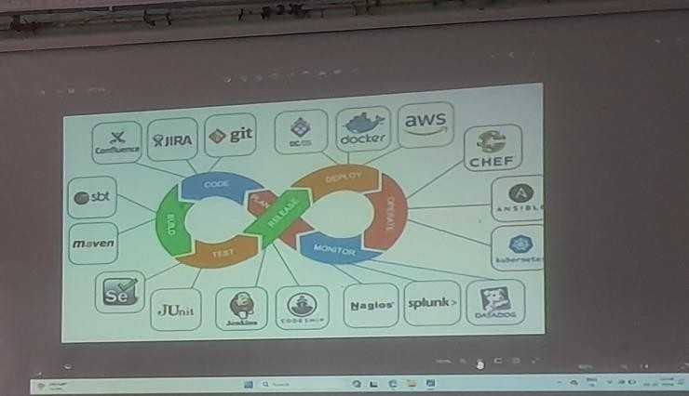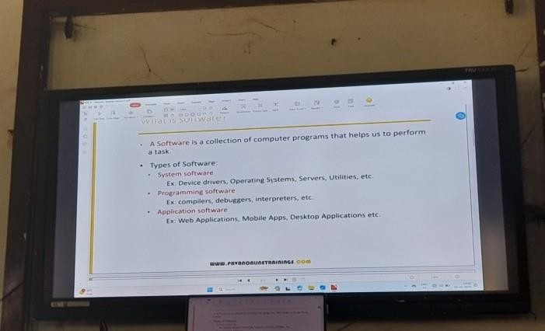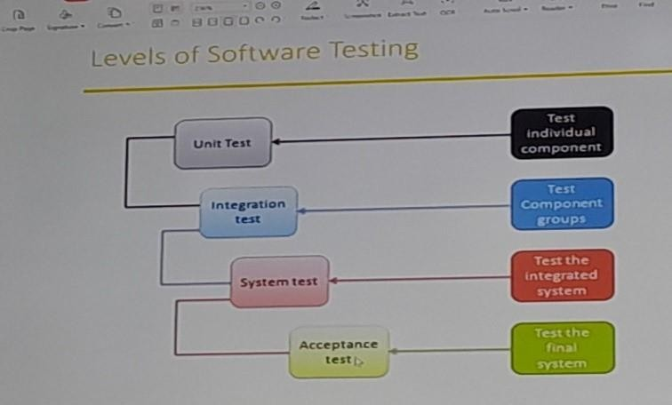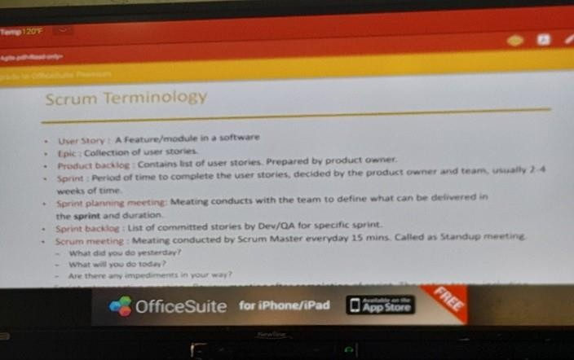

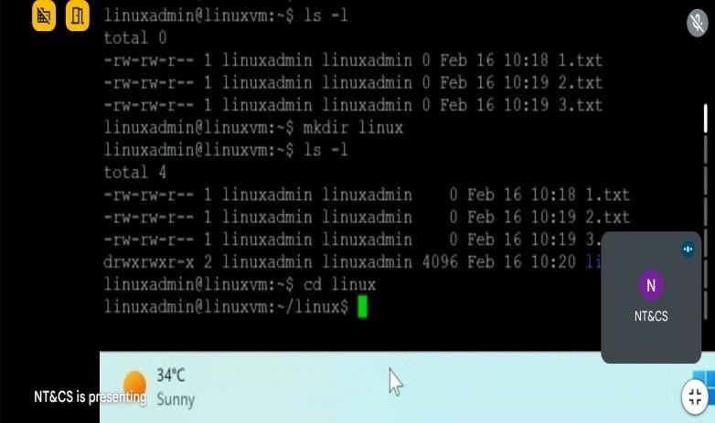 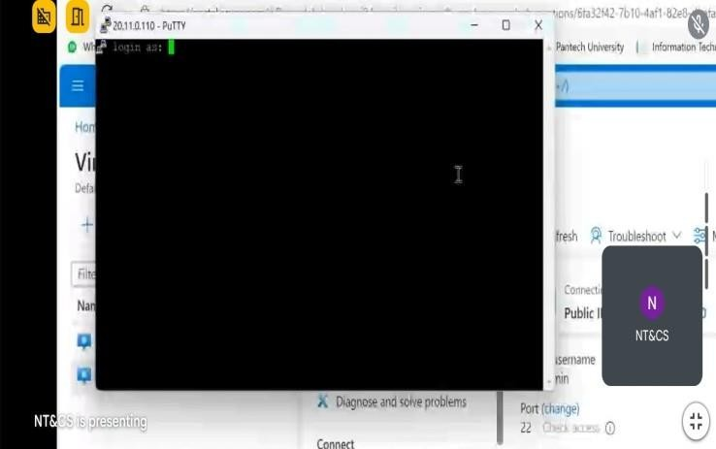

**https://meet.google.com/daf-rfoe-bje**

**/daf-rfoe-bje**

**https://meet.google.com**

# EVALUATION

**Internal & External Evaluation for Semester Internship**

## Objectives:

* Explore career alternatives prior to graduation.
* To assess interests and abilities in the field of study.
* To develop communication, interpersonal and other critical skills in the future job.
* To acquire additional skills required for the world of work.
* To acquire employment contacts leading directly to a full-time job following graduation from college.

## Assessment Model:

* + There shall be both internal evaluation and external evaluation
  + The Faculty Guide assigned is in-charge of the learning activities of the students and for the comprehensive and continuous assessment of the students.
  + The assessment is to be conducted for 200 marks. Internal Evaluation for 50 marks and External Evaluation for 150 marks
  + The number of credits assigned is 12. Later the marks shall be converted into grades and grade points to include finally in the SGPA and CGPA.
  + The weightings for Internal Evaluation shall be:
    - Activity Log 10 marks
    - Internship Evaluation 30 marks
    - Oral Presentation 10 marks
  + The weightings for External Evaluation shall be:
    - Internship Evaluation 100 marks
    - Viva-Voce 50 marks
  + The External Evaluation shall be conducted by an Evaluation Committee

comprising of the Principal, Faculty Guide, Internal Expert and External Expert nominated by the affiliating University. The Evaluation Committee shall also

consider the grading given by the Supervisor of the Intern Organization.

* + Activity Log is the record of the day-to-day activities. The Activity Log is assessed on an individual basis, thus allowing for individual members within

groups to be assessed this way. The assessment will take into consideration the individual student’s involvement in the assigned work.

* + While evaluating the student’s Activity Log, the following shall be considered -
  1. The individual student’s effort and commitment.
  2. The originality and quality of the work produced by the individual student.
  3. The student’s integration and co-operation with the work assigned.
  4. The completeness of the Activity Log.
  + The Internship Evaluation shall include the following components and based on Weekly Reports and Outcomes Description

1. Description of the Work Environment.
2. Real Time Technical Skills acquired.
3. Managerial Skills acquired.
4. Improvement of Communication Skills.
5. Team Dynamics
6. Technological Developments recorded.

# MARKS STATEMENT

**(To be used by the Examiners)**

# INTERNAL ASSESSMENT STATEMENT

### Name of the Student : Programme of Study : Year of Study :

**Group :**

### Register No / H.T. No : Name of the College :

**University :**

|  |  |  |  |
| --- | --- | --- | --- |
| ***Sl. No*** | ***Evaluation Criterion*** | ***Maximum Marks*** | ***Marks Awarded*** |
| 1. | Activity Log | 10 |  |
| 2. | Internship Evaluation | 30 |  |
| 3. | Oral Presentation | 10 |  |
|  | GRAND TOTAL | 50 |  |

Date: Signature of the Faculty Guide

# EXTERNAL ASSESSMENT STATEMENT

### Name of the Student : Programme of Study : Year of Study :

**Group :**

### Register No/ H.T. No : Name of the College :

**University :**

|  |  |  |  |
| --- | --- | --- | --- |
| ***Sl. No*** | ***Evaluation Criterion*** | ***Maximum Marks*** | ***Marks Awarded*** |
| 1. | Internship Evaluation | 80 |  |
| 2. | For the grading giving by the Supervisor of the Intern Organization | 20 |  |
| 3. | Viva-Voce | 50 |  |
|  | TOTAL | 150 |  |
| **GRAND TOTAL (EXT. 50 M + INT. 100M)** | | **200** |  |

Signature of the Faculty Guide

Signature of the Internal Expert

Signature of the External Expert

Signature of the Head of the Department with Seal